Linear Classifier
Background and Method Introduction
A linear classifier is often used in machine learning. This algorithm is famous for machine learning tasks like classification. Practical uses could be using it for classifying documents, images, or any other form of data. Classification in a linear classifier is done based on what feature points in the image are alike i.e linear combination of features.
In our assignment, we have used the CIFAR-10 dataset and we are using this dataset to classify different types of images present in the input dataset.

Dataset and Tasks Description:
As mentioned earlier, we are using CIFAR-10 dataset in the assignment. This dataset consists of many images . It is of size 32 * 32 pixels and has a total number of images of 60,000. Out of these 60000 total images , 50000 are for training and 10000 are used for testing the model. Total classes of images present in the dataset is 10.

We have to implement a linear classifier for this dataset and the output should map
Every input image has to be mapped to its specific class once it is given to the model. For the sake of achieving this accuracy the model is trained properly using 50000 images in this case and then 10000 images are inputted to the model for testing.
In the code, the first code is done by implementing the linear classifier algorithm .
After checking the output of this code, the second code is implemented by adding
Few changes that result in an output with better accuracy but unfortunately scenario 1 gives a lower accuracy. Scenario 2 again the model parameters are tweeked and we successfully obtain a higher accuracy of output with a decreased amount of loss.
Algorithms Used

Algorithms used are softmax regression, simple linear classifier algorithm , normalisation etc.
Softmax regression is used to convert logits into probabilities. It extracts the predicted value of the probability of correct class and calculates negative log of the probability.

Simple linear classifier :-
A linear classifier takes in input images in this case and classifies them into classes . For this specific task it uses a linear classifier i.e, a linear decision boundary in such a way that the input data classes do not overlap.

Cross-Entropy loss
In a classification model, cross entropy loss is used for various reasons. Majorly it is used for measuring how well the performance is of the classification model. It will adjust the weights and try to minimise what is accurate and the predicted value.

Code Implementation

Results
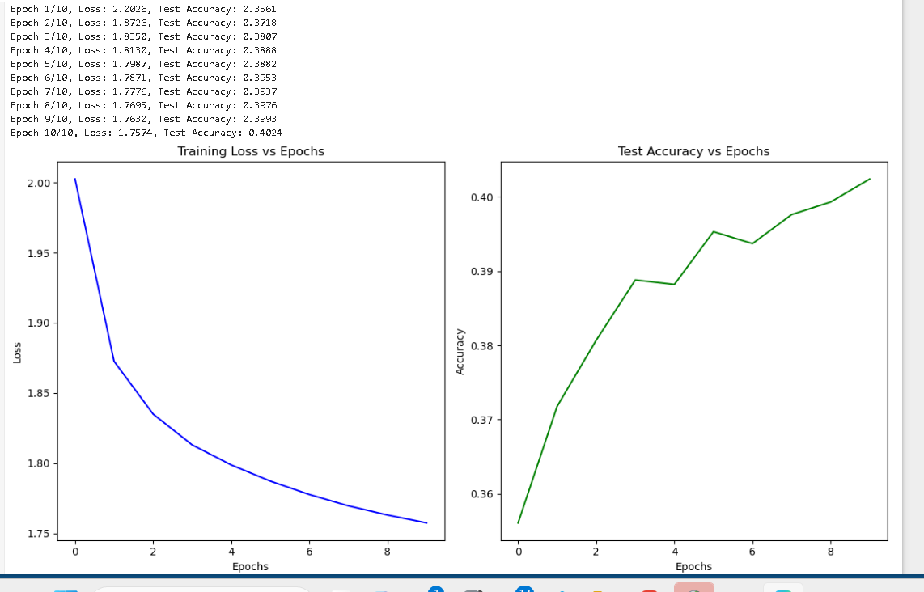
BatchSize = 64
Learning rate = 0.001
epochs = 10
regularization_strength = 0.001
Accuracy obtained in this case is 0.4024. and loss obtained is 1.7574

Scenario 1 output
Decreased accuracy
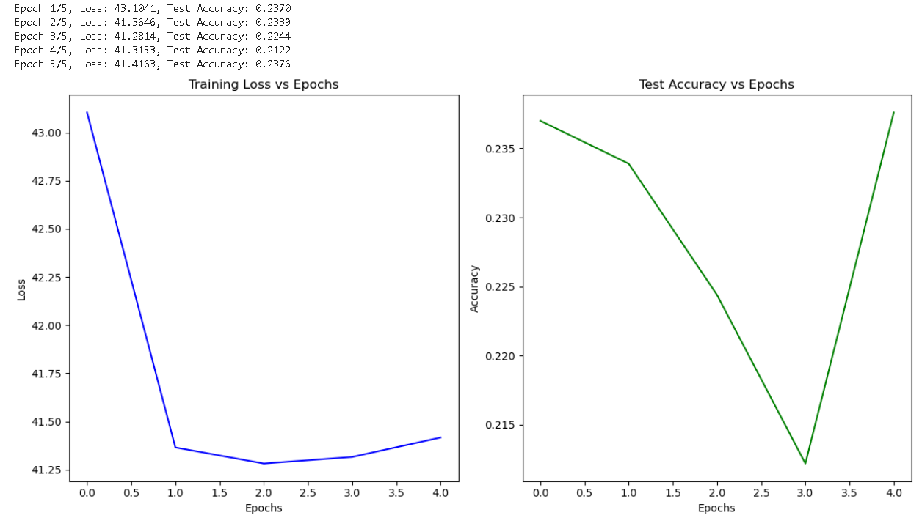
We try to increase accuracy by adjusting the parameters. The parameters are adjusted as follows.
Batchsize = 64
Learning rate = 2
Epochs = 5
regularization_strength = 0.0001
But unfortunately, accuracy obtained is much lower than the previous value. Accuracy is 0.2376 and loss is 41.4163

Scenario 2
Increased accuracy
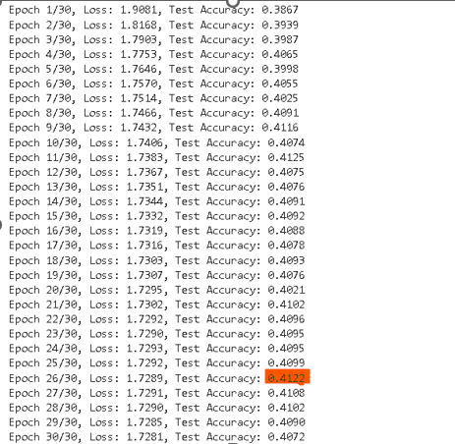
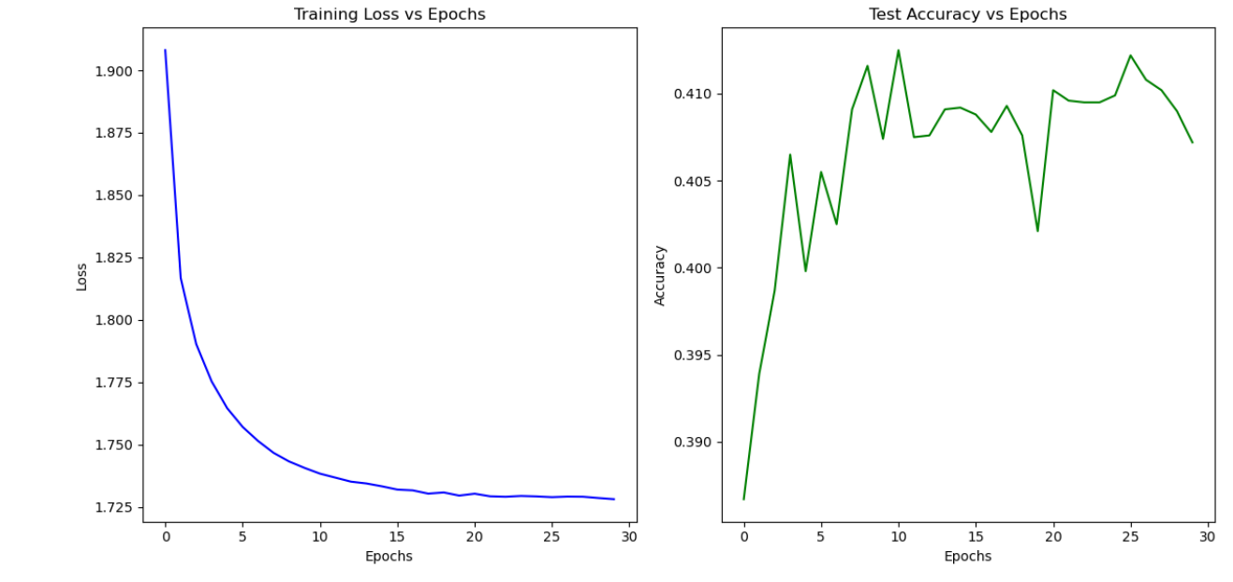

We try to increase accuracy by adjusting the parameters. The parameters are adjusted as follows.
Batchsize = 128
Learning rate = 0.01
Epochs = 30
regularization_strength = 0.01
Accuracy obtained is higher than the previous value. Accuracy is 0.4072 and loss is 1.7281

Methods of Improvements:
Increased Batch size
Increased the learning rate
Increased number of epochs from 5 to 30
Increased regularization strength to 0.01
Got the accuracy from 0.4024 to 0.4122

References
https://en.wikipedia.org/wiki/Linear_classifier
Cross-Entropy Loss Function in Machine Learning: Enhancing Model Accuracy | DataCamp
AI tools

